**S-Application class topology**

A SiESoCom application(S-app) is a scalable, multi-tier, AI-centric application deployed as various managed entities on various hosts, per the topology bloc diagram below.

The purpose of this document is to guide a SiESoCom system integrator through the instantiation of such an application.

Note: The operating instructions for a S-app are out of the scope of this document.

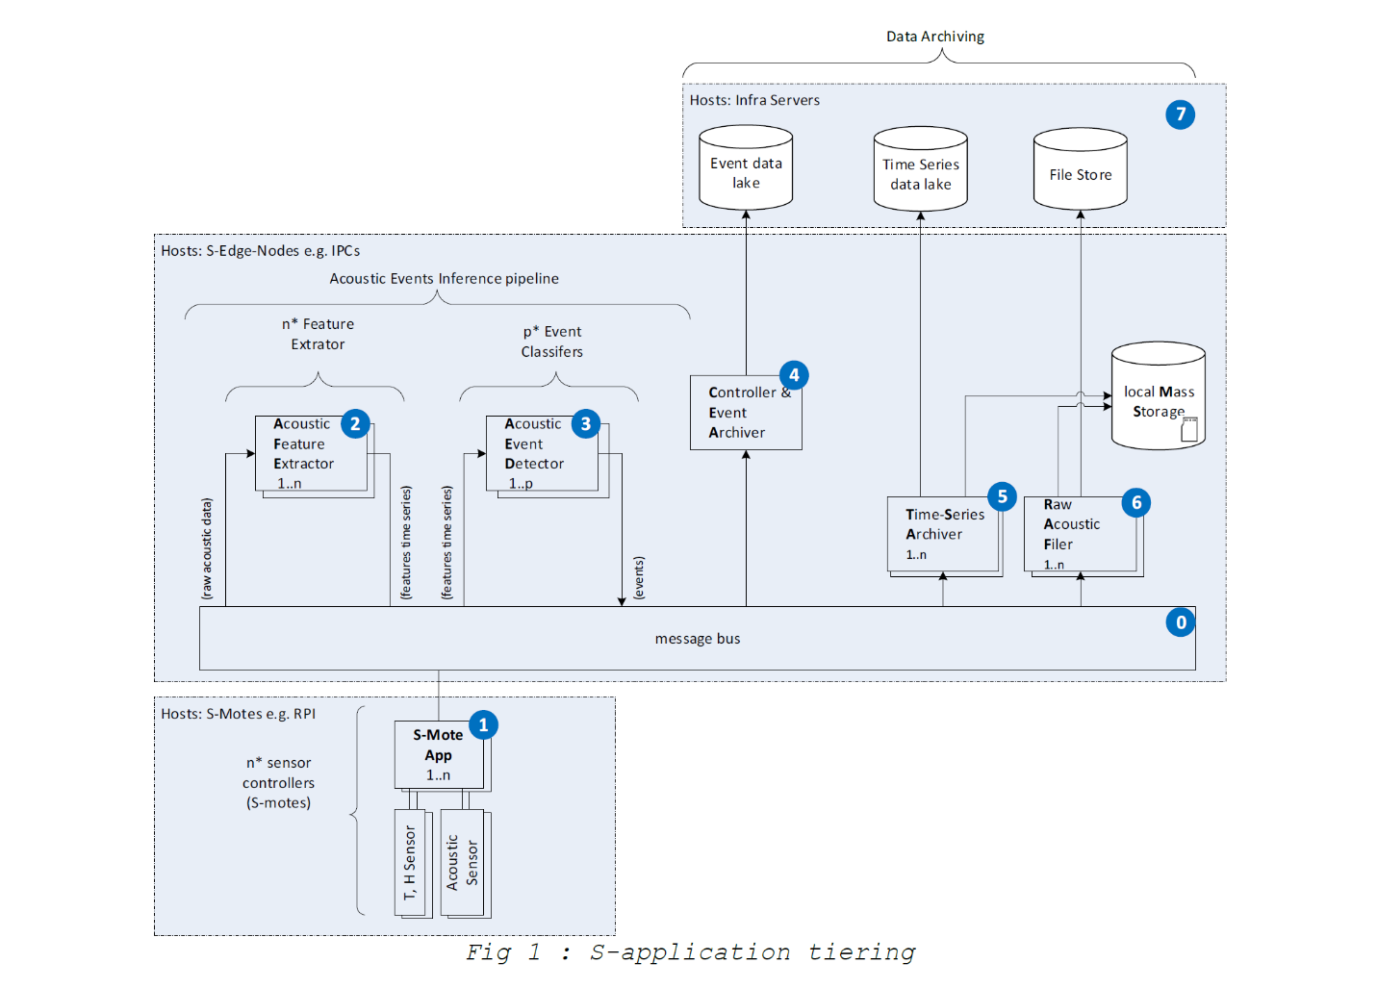

**S-Application tiering**

This section features a short description of each tier of the S-Application.

*Note: All the tiers of a SiESoCom application are grouped into a 'setup' M3 entity. This grouping is used by M3 Infrastructure to automated and simplify the inter-tier communication.*

**Tier #0**: **"Message Bus"** is a managed containerized application deployed on any S-Edge-Node of the user account that implements a message-based communication. Its system role is to support the communication between each tier of the S-application. Cardinality = 1:1

**Tier #1**: **"S-Mote App"** is a managed data acquisition application deployed on a managed device. This tier is implemented as Raspberry Pi-based sensor controllers loaded with the S-Mote application software and connected to acoustic, temperature and humidity sensors. Its system role is to supply the processing tiers with raw data (acoustic or time-series of T, H). Cardinality = 1:n

**Tier #2**: **"Acoustic Feature Extrator"** (AFE) is a managed containerized application deployed on any S-Edge-Node of the user account that implements the first node of the acoustic event inference pipeline. Its system role is to feed the acoustic event detector (AED) with featurized data(e.g.spectral lines, autocorrelation profiles..). Cardinality = 1:n

**Tier #3**: **"Acoustic Event Detector"** (AED) is a managed containerized application deployed on any S-Edge-Node of the user account that implements the second node of the acoustic event inference pipeline. Its system role is to detect and classify acoustic events it has been trained to infer. Cardinality = 1:n

**Tier #4**: **"Controller & Event Archiver"** (CAD) is a managed containerized application deployed on any S-Edge-Node of the user account that implements administration tasks for the setup. Its system role is to create and inject message bus credentials to any newly commissioned tiers and also to archive the inferred acoustic events into the infra event data lake. Cardinality = 1:n

**Tier #5**: **"Time-Series Archiver"** (TSA) is a managed containerized application deployed on any S-Edge-Node of the user account that implements the persistence interface for S-mote time series. This persistence is mapped on the infra time-series data lake, the infra file store or in a locally mounted mass storage device, depending on operator's choice. Its system role is to archive data for monitoring the application as well as for training various AI alogorithms. Cardinality = 0:n

**Tier #6**: **"Raw Acoustic Filer"** (RAF) is a managed containerized application deployed on any S-Edge-Node of the user account that implements the persistence interface for S-mote raw acoustic data. This persistence is mapped on the infra file store and/or in a locally mounted mass storage device. Its system role is to archive acoustic data for training various AI alogorithms. Cardinality = 0:n

**Tier #7**: **"Infra Data Archiving"** is a set of SaaS services, part of the S-application infrastructure, deployed on either public or private servers Siemens Confidential and Proprietary Page 5 of 23

that implements the long term , mass archiving of SiESoCom acoustic events and meta-data.

*Note: As the S-application progresses from acoustic event detection to system event prediction, more tiers will emerge, in particular tiers involved in the prediction stage of SiESoCom*